INTEGRITY CONSTRAINTS
Data integrity means accuracy, reliability and consistency of data which is stored in the database. Integrity constraints offer a means for ensuring that modifications made to the database by authorized users do not result in the loss of data consistency.
Need of Integrity Constraints
Many users enter data item in database which may results in inconsistencies. Therefore, data insertion, updating and other processes have to be performed in such a way that data integrity is not affected. For this integrity checks are made at data level by checking the value to certain specify rule.
Types of Data Integrity
There are different types of data integrity which are given below.
- Domain Integrity Constraint
Domain constraint defines that the value taken by the attribute must be the atomic value from its domain. It defines the domain or set of values for an attribute. In domain integrity, you define data type, length or size, here null values are allowed, is the value unique or not for an attribute.
Consider the following employee table
EMP_ID | NAME | AGE
E101 | Amit | 30
E102 | Aman | 32
E103 | Akshay | 29
E104 | Rahul | Q

Here, the domain constraint is that in EMP_ID E104, in AGE ‘Q” is not allowed because in age attribute, only integer values can be taken.

- Entity Integrity Constraint
Entity integrity constraint states that primary key can’t be null. It ensures that a specific row in a table can be identified. There can be null values other than primary key fields. Null value is different from zero value or space. The two main properties are:
• The primary key is not null, no component of the primary key may be set to null.
• The primary key for a row is unique; it does not match the primary key of any other row in the table.
The first property ensures that the primary key has meaning, has a value; no component of the key is missing. The uniqueness property ensures that the primary key of each row uniquely identifies it; there are no duplicates. Any operation that creates a duplicate primary key or one containing nulls is rejected. The system enforces entity integrity by not allowing operations (INSERT, UPDATE) to produce an invalid primary key.
For example, consider there is a relation “EMP” Where “Emp_id” is a primary key. These must not contain any null value whereas other attributes may contain null value e.g “Age” in the following relation contains one null value.

EMP_ID | NAME | AGE
E101 | Amit | 30
E102 | Aman | 32
E103 | Akshay | 29
E104 | Rahul | NULL

In the above table, in EMP_ID E104, in age attribute, NULL values are not allowed.

- Referential Integrity Constraint
The referential integrity constraint is specified between two tables and it is used to maintain consistency among rows between two tables. The properties are:
• You can’t delete a record from a primary table if matching record exist in a related table.
• You can’t enter value in foreign key field of the related table that doesn’t exist in the primary key of the primary table.
• You can’t change a primary key value in the primary table if that record related record.
• You can enter a value in foreign key, specify that the record is unrelated.
• You cannot update or delete a record of the referenced relation if the corresponding record exists in the referencing relation.
• You cannot insert a record into a referencing relation if the corresponding record does not exist in the referenced relation. For example, consider there are two relations ‘EMP’ and ‘DEPT’ .Here, relation ‘EMP’ references the relation ‘Department’.

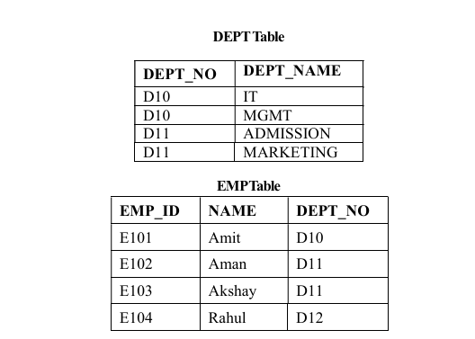

Here in the above table, the relation ‘EMP’ does not satisfy the referential integrity constraint because in relation ‘DEPT’, no value of primary key specifies department no. 12. So here, referential integrity constraint is violated.

4.Key Integrity Constraint
• In the relational table, a primary key contains a null and unique value in the relational table.
• In the entity set, there can be multiple keys and one key must be primary key.
•Key integrity constraint are the entity set which are used to detect an entity within its entity set (uniquely).
For example, given below is the employee table, which contains attributes like EMP_ID, NAME and DEPT_NO.

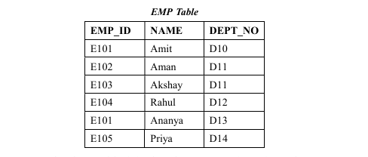
From the above table, it is clear that EMP_ID is a primary key. It means each entry in this domain should be unique. But it violates the rule.

